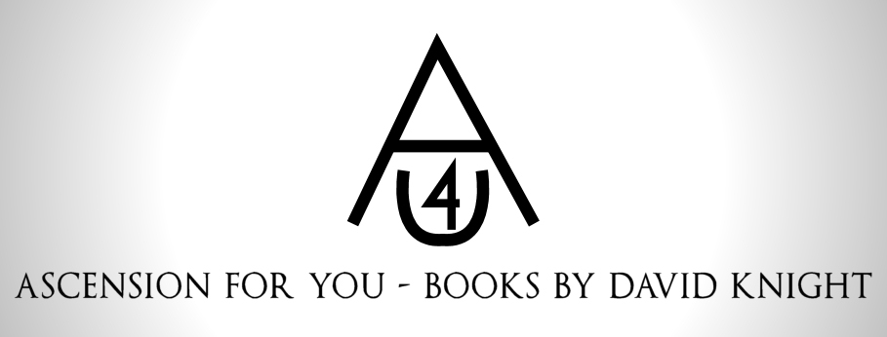

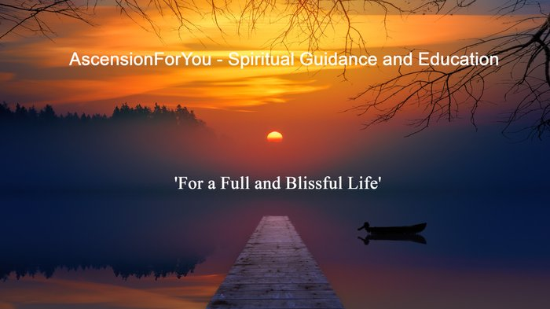
What I have been up to!

Happy April Fools’ day everyone! Well, I can’t believe it’s been 3 months since the last quarterly Newsletter.
On a personal front I had the first Covid Jab … must admit I wasn’t keen at all … especially after all the recent blood clot scares etc. Suffice to say that it made me feel awful for days! Guess it can’t agree with everyone!
On the book front, since I last wrote I have been concentrating on revamping as many of my back catalogue as possible. To aid this process I have had the support of two wonderfully creative people … Rachel Hardcastle of Curious Cats Books and Nathan Dasco from Book CoverMall.
Rachel has been a real rock with all the ‘to and fro’ regarding new formatting around the eBooks and paperback versions of Pathway, Leave the Body Behind and tweaking A pocket Full of God too. Starting next week, we hope to continue these with Deliverance of Love, Light and Truth. Now, bearing I mind Pathway and Deliverance date back to 1996 it’s been a monumental effort, with dozens and dozens of hours on both sides to bring them up to higher standard … not in terms of the spiritual guidance and education but with layouts etc.
Nathan too is superb at what he does … and his eye for detail and creativity on the covers he puts together really is awesome. Some of the new covers are below.
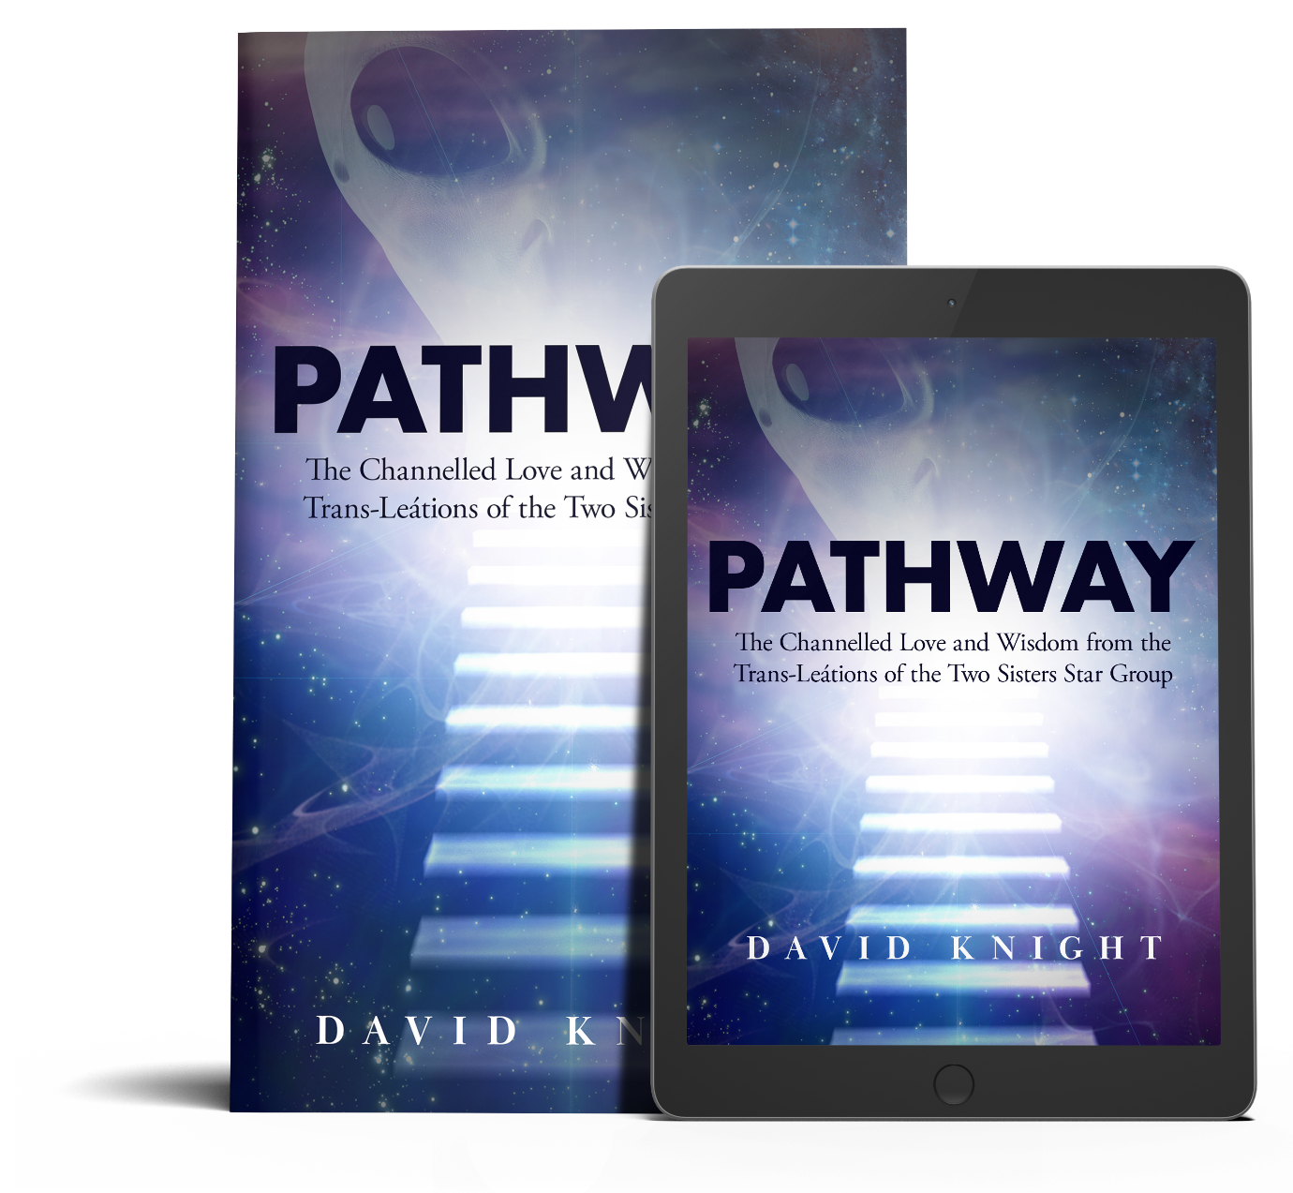

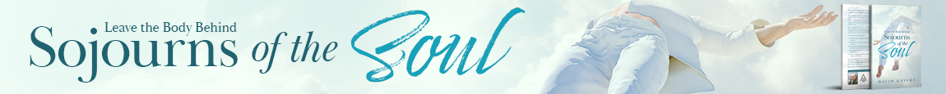

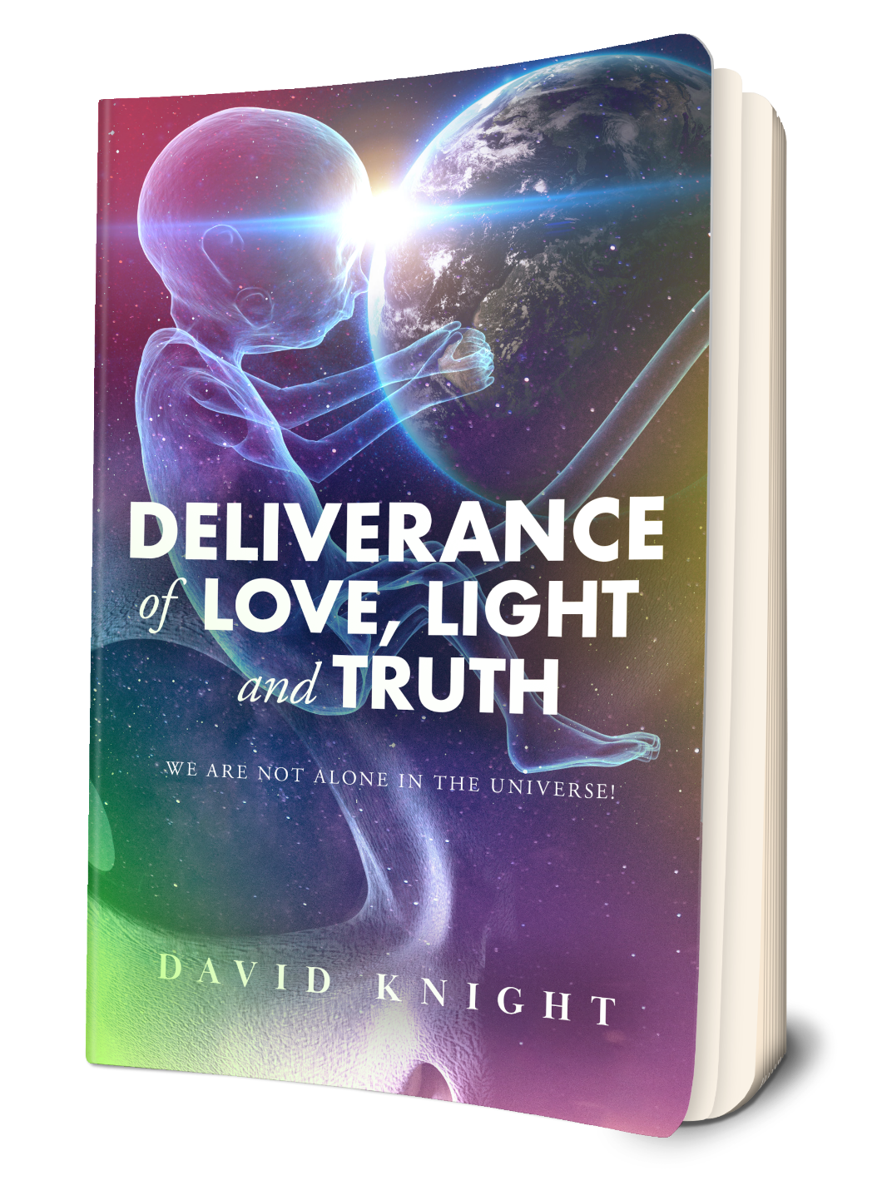
In addition to this I have managed to set up the Leave the Body Behind: Sojourns of the Soul as a NEW Audiobook! Narrator again for this one is Richard Dalkey, another great professional. He reads with great clarity, and with just the right amount of empathy and compassion. If you end up getting this for your collection you might laugh at the southern accent he provides in speaking as myself when I meet with Jesus!
To be honest, I think Leave the Body Behind is one of my favourite books as it encompasses such beautiful imagery and leads you to experience a small piece of paradise … venturing into Heavenly realms. If you would like to know what it feels like to hold the hand of the Lord, then this gives you a brief glimpse of such pure unconditional love.
As its Easter Sunday coming up, I intend to attach an AudioBook extract for you all … so you can have a special preview listen! NB: Officially it goes on general sale on places like Apple Books, Findaway Voices -about 40 plus avenues in fact- on Sunday 4th 2021 … which is quite apt. (Though Audible have it available now!)
I hope you get an Easter egg or two. I gave up chocolate and crisps for lent so I am going to let my hair down and scoff a few ha ha! Have a lovely peaceful Easter … where you can celebrate the Ascension of the Lord, a renewed faith and hope for the future. Spring is wonderful time of year … a time for new beginnings for us all. Love and light to you all x
PS. Next Newsletter is 1st July.

From my speaking heart…
You are Already Complete.

"As Easter is an important period of time within the Earth’s calendar, millions of people will wish to refocus, or re-align their thoughts (and more importantly their hearts), to remember Lord Jesus upon the cross and his subsequent resurrection. In fact, no matter what religion you follow, one’s faith can be strengthened, or even renewed at any time, but more so now. How much emphasis this bears in your life is also down to the individual beliefs and emotions flowing through your being, which will help you seem more (or possibly less), connected to me, the source and energy of all things.
However, even if a soul seems lost, confused, or at the point of giving up, their spark can still be found, so at this Easter time, a special reflection of your faith will mirror in many a heart’s flame.
Try to rediscover your inheritance, for the reconnection to bliss may even form part of one’s deepest, darkest hour. You only require an open heart, free will, compassion, and forgiveness, but are these all too much? No! For such things are within you all, so please act upon them once they have been recognized inside oneself.
Therein lies the choices you can make, and these are clear for the soul. The Lord did not falter in his quest, goal, and ‘work’ to bring my love, vision, insight, and light to you all. In recognizing the truth upon the cross, you rediscover your own: one light and one love in all, from all, and to all.

Once known, the individual must discount and deny, or embrace and accept, who, what, and the why they ‘exist’. Understand, when sunshine falls upon your face, you feel uplifted, happy, content … but when the eternal light radiates and rests inside your heart, you will realize you are already complete. Amen."
----------------------------------------------------------------------------------------------------------------
Remember ... the Easter period renews thoughts over the resurrection of Christ (which was a victory over death of the body), and the miracle of being ‘one’ with me!

----------------------------------------------------------------------------------------------------
PS. If you have any burning questions on your own spiritual development or are concerned about any aspect of your Earth-plane journey, let me know.
PPS: Please could you share this newsletter on any of your social media feeds below ... it just might help another person when they need it most - thank you in advance! (Dave - AFY)
Follow Us

Share Via:

Check out my website / free book

Join me on the Wix mobile app to stay updated, share posts and keep in touch.
Download & Join

